**Designed document**

**Project goal:**

**measure typing speed of user on keyborad ,**

**and add some features such as filters type**

**and analytics for progress typing user.**

**Project Design:**

**the project will build using react library**

**its will include these pages:**

**1-- sign in page:will include form for sgin in operation**

**2-- sign up page:will include form for sgin up operation**

**3-- home page: that includes these sections:**

**\*-- filter section:will filter type of paragraph**

**[]--such as what paragraph should includes (numbers,punctuation,upper cases)**

**[]--time test that will be by selected time e.g (15,30,60,120) seconds**

**\*-- paragraph section:the section will do the typing test**

**4-- settings:allow change theme and enable sounds**

**5-- profile:display analytics for progress typing user per days**

**\*-- every page ofcourse have header and footer**

**Project total available time:**

**6 days * 8hours = 48 hours**

**Project milestones:**

**1-- build typing speed test for paragraph:**

**task 1:measrue speed for paragraph:**

**time:2 hour**

**difficulty:super important**

**dod:create meassureSpeedWord function that include these steps**

**[]-enable stopwatch that count a seconds**

**[]-let user start typing**

**[]-count typed words**

**[]-disable stopwatch when user finish writing**

**[]-convert the time to minutes**

**[]-return how much typed words per minutes**

**task 2:measure accuracy for paragraph**

**time:1 hour**

**difficulty:super important**

**dod:refactor first task function by these steps:**

**[]-while the user typing , the funciton will count number of incorrect characters**

**[]-calculate the accuracy by deviding count to length of word**

**[]-when user finish typing the function will return also the accuracy as percentage**

**---estimated time : 3 hours**

**2-- create layout and pages project:**

**task 1:create home Page:**

**time:2 hour**

**difficulty:super important**

**dod:create filter and paragraph sections:**

**[]- after user select type of test from filter**

**[]- we will fetch an appropriate paragraph by api**

**task 2:create the header**

**time:1 hour**

**difficulty: important**

**dod:contain logo and navbar**

**task 3:create the settings page:**

**time:2 hour**

**difficulty: important**

**dod:create theme button and button sounds sections**

**[]-the theme button will convert the theme dark,light.**

**[]-button sounds will enable or disable sound clicking**

**task 4:create a structure of stored data and sgin up page**

**time: 2 hours**

**difficulty:less important**

**dod:build createUser funtction and sgin up form:**

**[]-after user fill his details using the form [name,mail,password]**

**[]-using creatUser function will create new account:**

**[]--checking if current user already exist**

**[]--if not exist send the user to the server in order to save it**

**[]--if user exist show to him an appropriate message**

**task 5:create sgin in page**

**time: 1 hours**

**difficulty:less important**

**dod:build getUser funtction and sgin in form**

**[]-after user fill his details using the form [name,mail,password]**

**[]-using creatUser function will create new account:**

**[]--checking if current user already exist**

**[]--if not exist show to him an appropriate message**

**[]--if user exist go to home page**

**task 6:create the profile page:**

**time: 10 hours**

**difficulty:less important**

**dod:user detials and analytics typing speed for per day:**

**[]-show user detials such as name email**

**[]-display chart of analytics typing per day**

**task 7:create the footer**

**time:20 minutes**

**difficulty: less important**

**dod:contain rights reserved and some text**

**---estimated time : 18.3 hours**

**3--customize my template:**

**time:16 hours**

**difficulty: important**

**\*--total estimated time:37.3 hours**

**Scheduled tasks per day:**

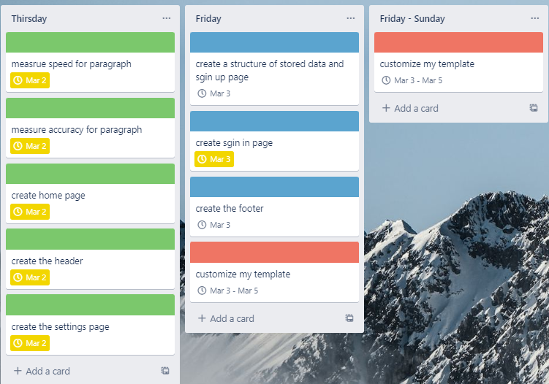

**Site map:**